Sprint 1 - Endurance Design Document

November 12, 2019

Team 1 – Jenni, Griffin, and Angaya

Executive Summary

Project Overview

The robot in this project is activated and programed through the Sphero Edu app. Here all team members will collaborate to create an algorithm that is developed and tested to fulfill all functional requirements. The team’s focus will be on the endurance of the robot in sprint one. To observe the robot’s endurance through its circumnavigation, the robot must travel around a given perimeter of a rectangle properly. Once robot passes through the directed path and ends in at the original starting point, the team can verify the algorithm works well. Hence, the robot proves its endurance. We demonstrate this to the class and the professor with documentation of the robot’s run to demonstrate the effectiveness of our algorithm and endurance of our robot during its sprint.

Purpose and Scope of this Specification
In scope
This document addresses requirements related to phase 1 of the Software Development Project, Endurance sprint 1. Our audience is class CS-104 01.

Out of Scope
Phase 2 & 3 of the system development project is not meet in this document.

Product/Service Description

The robot should be charged and connected to the Sphero app to verify its capability to execute the algorithm. Additionally, to be certain the robot is not affected during its sprint, there must not be any notable object obstructing its navigation. Any barriers in the robot’s pathway could pose a possible delay to the robot’s potential of fully achieving the functional requirements. If physical barriers prove an issue, all team members will work to improve the algorithm to suit accordingly.

Product Context

The robot is relatively similar to other products in that it is programed through a block code program of a user-friendly app. In the Sphero.edu app, team members create an algorithm to direct the robot through its sprint. Thus, the robot is dependent on the app and its user. Other outside sources that are as important include Bluetooth connection. Without the link of robot to app, we cannot work on test runs. Connection of robot to app is just as important as an effective algorithm.

User Characteristics

General customer profile includes that of a Freshman student in CS-104 01 at Monmouth University with about 2-3 months worth’s of experience on the Sphero.edu app and block code.

Assumptions

Easy access to the Sphero.edu app is expected to ensure a smooth process in creating an algorithm for the robot. Whilst the main operating system is working properly, the user should easily be able to adjust if necessary. Large spaces, or lack thereof, also may force the user to adjust distances written in our algorithm. Depending on the setting, the user may have to observe closely to note if it poses an issue.

Constraints

There is a number of constraints team members have noted: trouble connecting the app to the robot, block code program on sphero.edu is not executed properly, lack of accessibility to the app, not being able to create an efficient algorithm, all team members not being able to physically meet, lack of space at testing cite, and a potential difference of measurements from software development project outline.

Dependencies

The robot must be fully charged before every test run. The user must make sure the robot is connected to the Sphero app to confirm a successful run. The block code algorithm must also be well-organized prior to a test run. The block code, in addition, should be according to the software development project outline, otherwise not effective.

Requirements

Functional Requirements

Req# | Requirement | Comments | Priority | Date Rvwd | SME Reviewed / Approved
ENDUR_01 | Robot must be fully charged + be in a spacious area | No objects should be in pathway | 1 | 11/10/20 | Members reviewed + approve
ENDUR_02 | Robot must start on given starting point and say “ready set go” with green light on | Starting point | 1 | 11/10/20 | Members reviewed + approve
ENDUR_03 | Robot must travel 0 degrees at a 65 speed for 3 sec. to first destined point, then delay for 2 sec. | First destination | 1 | 11/10/20 | Members reviewed + approve
ENDUR_04 | Robot must travel 90 degrees at a 66 speed for 3 sec. to second destined point, then delay for 2 sec. | Second destination | 1 | 11/10/20 | Members reviewed + approve
ENDUR_05 | Robot must travel 180 degrees at 64 speed for 3 sec. to third destined point, then delay for 2 sec. | Third destination | 1 | 11/10/20 | Members reviewed + approve
ENDURE_06 | Robot must travel 270 degrees at a 68 speed for 3 sec. to fourth and last destined point, then delay for 2 sec. (Robot must now be at original starting point) | Fourth & final destination | 1 | 11/10/20 | Members reviewed + approve
ENDUR_07 | Light must change to red and say “I’m done and I need water” |  | 1 | 11/10/20 | Members reviewed + approve
ENDUR_08 | Program ends |  | 2 | 11/10/20 | Members reviewed + approve

Security

Protection

Pathway should be clear for the robot to pass. There should be no physical barrier keeping the robot from executing functional requirements. Robot should be closely observed during its run to affirm the robot does not collide with any outside object. User should also keep algorithm under their account in a private folder to make certain there is no threat to the robot. This makes sure outside sources cannot have access to the robot’s program.

Authorization and Authentication

Team members will use Github.com in-order to access all separate components of the project individually. Here all information will be easily accessible and will allow each team member to commit their work. One team member will create a repository to allow certain people access to the project documentation.

Portability

In this project downloading Shero.edu app is required. Block code language is also the most recommended for an orderly algorithm. In addition, a spacious environment is suggested as the sprint is based on endurance. Robot must also be cared for and not be damaged in any way, as that might affect performance.

Requirements Confirmation/Stakeholder sign-off

Meeting Date | Attendees (name and role) | Comments
11/10/20 | Griffin ( test algorithm program)  Angaya (flowchart)  Jenni (SDD) | confirmed all requirements

System Design

Algorithm

- Main Led = Green
- Robot speaks “ready set go” and wait
- Robot rolls at 0 degrees at 65 speed for 3sec.
- Delay for 2sec
- Robot rolls at 90 degrees at 66 speed for 3sec
- Delay for 2sec
- Robot rolls at 180 degrees at 64 speed for 3sec
- Delay for 2sec

- Robot rolls at 270 degrees at 68 speed for 3sec
- Main led = red
- Robot speaks “I’m done and I need water” and wait
- Program ends

System Flow

On github : https://github.com/jenniatz/Endurance

Software
The team used block code program on the Sphero.edu app. Through the app, we can control the robot’s travel of speed, distance, and time.

Hardware
The team uses a robot that connects to the Sphero.edu app through Bluetooth. The user also uses his/her phone to use the program easily, thus controlling the robots performance.

Test Plan

Reason for Test Case | Test Date | Expected Output | Observed Output | Staff Name | Pass/Fail
To observe if robot can reach the first destination with color & speaking requirements implemented | 11/10/20 | Robot completes its task in reaching the first destination, whilst speaking and color change requirements achieved | The robot reaches point one, speaks, and changes color | Griffin | Pass
To observe if robot can reach the second destination | 11/10/20 | Robot completes its task in reaching the second destination | The robot reaches point two | Griffin | Pass
To observe is robot can reach the third destination | 11/10/20 | Robot completes its task in reaching the third destination | The robot reaches point three | Griffin | Pass
To observe if robot can reach the fourth destination with color & speaking requirements implemented | 11/10/20 | Robot completes its task in reaching the fourth destination | The robot reaches point four | Griffin | Pass
To observe if Robot ends at original starting point | 11/10/20 | Robot ends where it started | The robot ends where it began | Griffin | Pass

Task List/Gantt Chart
Sprint 1 Endurance Gantt project plan Template (1)
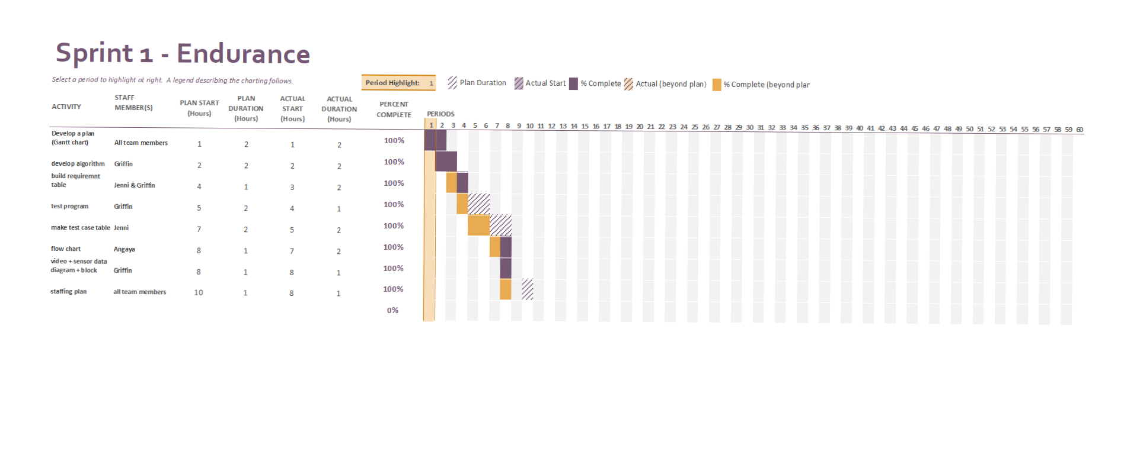

Staffing Plan

Name | Role | Responsibility | Reports To
Jenni | SDD | Fill out documentation in the SDD | Github repository called ‘Endurance’
Griffin | Create + Test Algorithms | Create algorithms + run sprint tests | Github repository called ‘Endurance’
Angaya | Flowchart | Create a flowchart of the algorithm | Github repository called ‘Endurance’

